KV6014 LOG TASK 2 · @DESIGNER(S) DELIVERABLE (COMPLETED DESIGN SPEC & UX DIFFERENTIATION)
Completed Design Specification, Competitor UX Differentiation & Developer Alignment Matrix
Project: ROSE Event Management Application (KV6014BHV31-GP6/event-management-app) | Forest Green (#1F5547) System
Response to Cease-and-Desist Scenario & Traceability Guarantee
To address the Log Task 2 competitor infringement challenge, this specification documents how our UX architecture differs fundamentally from commercial ticketing and generic form platforms, while maintaining 100% field-and-component alignment with the team's `frontend/live/` codebase and `/api/v1` FastAPI backend.

1. Competitor UX Differentiation Analysis Report
Aligned with the Project Manager's seven-competitor baseline (Ticket Tailor, Eventbrite, SimplyBook.me, CommCare, KoboToolbox, TextIt, and Ticket2U), our UX analysis evaluates why no single existing tool satisfies ROSE Foundation's B40 cervical screening workflow out of the box.
Platform | Primary UX Paradigm | Dual Quota Split UI (Online vs Offline) | Leader Outreach, Proxy & Reviewed OCR | Offline Check-In & Conflict Resolution UI
Ticket Tailor | Commercial event ticketing & entry | Standard ticket tiers only; no online/offline community pool isolation | Referral links & manual orders; lacks leader quota progress & OCR review gate | Offline check-in app exists, but native SMS is limited to UK/US and lacks conflict review UI
Eventbrite | Public event discovery & ticket sales | Single open inventory pool; online traffic can starve offline B40 access | Self-service attendee focus; no village leader WhatsApp/flyer reporting loop | Offline ticket scanning; heavy web assets unsuited to low-literacy proxy workflows
SimplyBook.me | Clinic & salon timeslot scheduling | Per-slot capacity limits; no split between public web and leader proxy pools | Supports guest booking & SMS, but lacks leader referral attribution & OCR intake | Online calendar centric; lacks preloaded offline field roster & conflict queue
CommCare | Frontline health worker case management | Case forms without transactional dual-pool slot ledger or automatic waitlist | Strong field forms, but lacks public low-bandwidth event discovery & referral hub | Robust offline storage, but requires custom app engineering to model event quotas
KoboToolbox | Humanitarian offline survey collection | Form submissions do not enforce atomic last-seat capacity locks on a server | Supports source fields & offline forms, but does not deduct leader quota allocations | Caches form uploads only; no preloaded attendee check-in roster or walk-in release
TextIt | Two-way SMS / WhatsApp flow engine | Messaging engine only; no visual event setup or dual quota management UI | Automates SMS reminders, but has no printable flyer generator or OCR form review | No field staff roster search, attendance check-in, or conflict resolution interface
Ticket2U | Malaysian commercial ticketing & QR entry | Commercial ticket categories; no dedicated B40 offline community leader quota pool | Affiliate link tracking exists, but lacks self-reported flyer log & no-account OCR proxy | Supports QR check-in, but designed for commercial venues rather than offline rural clinics
ROSE Event Management App (Ours) | Low-resource NGO screening coordination (Web + SMS + Assisted) | Native `online_quota` & `offline_quota` split on event creation (`SCR-05`) and live monitor (`SCR-10`) | Unified Leader Hub (`SCR-08/09`): Referral URL + A4 Flyer + Amber-gated OCR Proxy + Flyer Log | Explicit `PENDING_SYNC` -> `SYNCED` / `CONFLICT` queue (`SCR-11`) with scoped roster revision

1.1 Five Core UX Originality Pillars (Evidence Against Infringement)
1. Dual-Pool Quota Isolation (`online_quota` vs `offline_quota`): Commercial platforms treat all registrants as a single self-service pool. Our UI physically separates `online_quota` (for digitally literate applicants on `registration.html`) from `offline_quota` (reserved for Community Leader proxy entry, reviewed paper OCR, and eligible walk-ins), preventing online sign-ups from crowding out vulnerable rural women.
2. Strict Separation of Self-Reported Flyers vs Verified Attribution: To solve ROSE's promotion black box without conflating flyer distribution with real turnout, our Organizer Dashboard (`SCR-10`) and Closeout Report (`SCR-12`) visually separate self-reported printed flyer counts (badged as `Self-reported · Unverified Reach`) from server-verified referral registrations and checked-in arrivals.
3. Human-in-the-Loop Paper OCR Proxy Registration (`US-07`): Rather than raw automated OCR ingestion or manual-only typing, `SCR-09` introduces a mandatory Amber Verification Gate: camera-extracted fields populate standard `ParticipantCreate` inputs with high-contrast review borders, requiring explicit Community Leader confirmation before deducting `offline_quota`.
4. Capacity-Driven Pause / Boost Outreach Signalling (`US-05`): When registrations reach >=80% capacity or lag below target, `SCR-10` equips ROSE Organizers with one-click Pause / Boost promotion signals directed to assigned Community Leaders, directly addressing the client's fear of over-promoting or under-promoting.
5. Honest Server-Authoritative & Offline Conflict State Machine (`US-09`): Neither Participant booking receipts (`SCR-07`) nor Organizer US-09 Event-Day offline check-ins (`SCR-11`, `role='organizer'`) ever display optimistic false success. Offline check-ins are badged `PENDING_SYNC (Stored locally)` until server reconciliation, and concurrent device edits surface an explicit `CONFLICT — Needs Review` resolution card.
2. Visual Design System, Figma Component Structure & Auto Layout Specification
In accordance with team constraints, the visual system preserves the exact Forest Green (`--green: #1F5547`) color architecture and `Georgia` serif heading hierarchy implemented in `frontend/live/styles.css`, while refining component elevation, status badges, quota meters, and accessibility focus states.
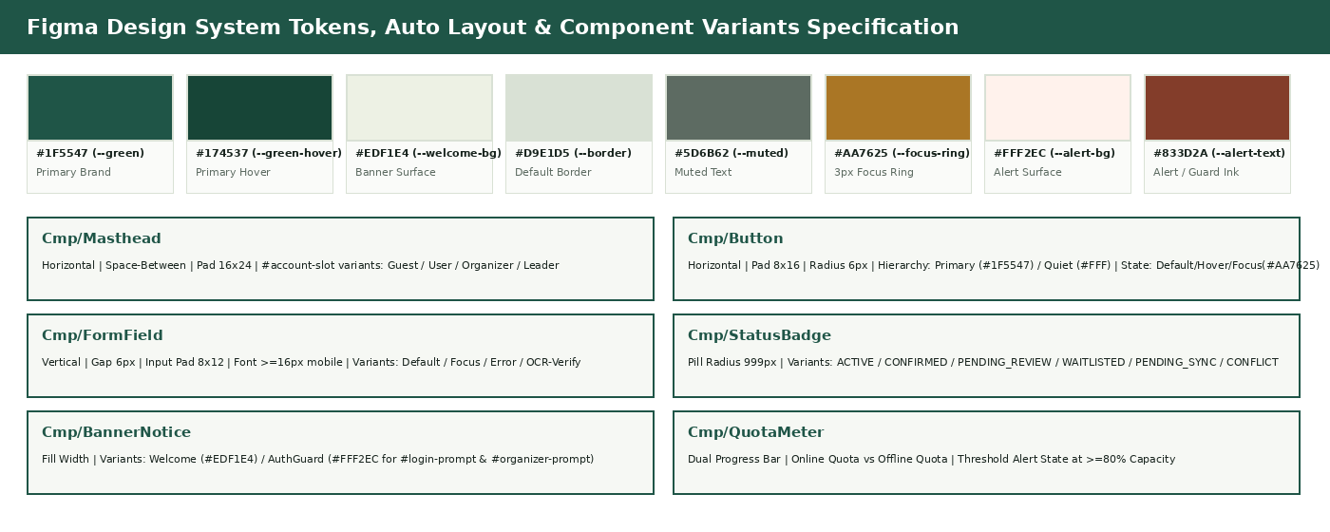
Figure 4: Figma Color Tokens, Typography Hierarchy, Auto Layout Parameters, and 8 Core Component Sets.
Token / Variable Name | Hex Code | Figma Style Name | Semantic Usage in UI & `frontend/live/styles.css`
--green | #1F5547 | Brand / Forest Green 700 | Primary buttons (`.button`), `.eyebrow` labels, active badges, quota progress fill
--green-hover | #174537 | Brand / Forest Green 800 | Primary button hover and active pressed state
--welcome-bg / --welcome-border | #EDF1E4 / #D9E2CF | Surface / Sage Tint 100 | Welcome card background (`index.html`), role summary banners, table header tint
--quiet-hover | #EDF1E8 | Surface / Quiet Hover 150 | Secondary button (`.button-quiet`) hover fill and progress bar track
--border | #D9E1D5 | Neutral / Sage Border 200 | Standard 1px border for cards, inputs, masthead divider, and tables
--muted | #5D6B62 | Text / Muted Slate 600 | Secondary descriptions, field constraints, `#results-summary`, timestamps
--ink / --white | #18241E / #FFFFFF | Text / Deep Ink & Pure White | Primary body/heading text (WCAG AAA >12:1 contrast) and card/input surfaces
--focus-ring | #AA7625 | A11y / Focus Gold 600 | Global keyboard focus ring (`3px solid #aa7625`, `outline-offset: 4px`)
--alert-bg / --alert-text / --alert-border | #FFF2EC / #833D2A / #DFBDAF | Status / Coral Alert | RBAC guards (`#login-prompt`, `#organizer-prompt`), `#not-accepting`, `CONFLICT` & errors
--wait-bg / --wait-text / --wait-border | #FDF6E7 / #8A5A10 / #E6C88A | Status / Amber Review | `WAITLISTED`, `PENDING_REVIEW`, >=80% quota alert, and OCR human verification gate
--sync-bg / --sync-text / --sync-border | #EEF0F8 / #344278 / #BFC6E0 | Status / Indigo Offline Sync | `PENDING_SYNC` local check-in queue badge and scoped roster header (`US-09`)

2.1 Figma Auto Layout & Component Variants Blueprint
Figma Component Set | Code Selector / Element | Auto Layout & Resizing Rules | Variant Properties & States
Cmp / Masthead | header.masthead.shell  #account-slot | Horizontal | Space-Between | Align Center | Pad 16x24 | MaxW 1080px (Fill) | AuthState = Guest | User | Organizer | Leader;  Viewport = Desktop | Mobile
Cmp / Button | .button  .button.button-quiet | Horizontal | Align Center | Pad 8x16 | Gap 8px | Radius 6px | Hug Contents | Hierarchy = Primary (#1F5547) | Quiet (#FFFFFF) | Danger;  State = Default | Hover | FocusVisible (#AA7625) | Disabled
Cmp / FormField | label + input / select / textarea | Vertical | Gap 6px | Fill Container; Input Pad 8x12, Radius 6px, Stroke 1px #D9E1D5 | FieldType = Text | Search | Password | Number | Datetime | Select | Textarea;  State = Default | Focus | Error | OCR-Verify
Cmp / StatusBadge | .status-badge  #detail-status | Horizontal | Pad 4x10 | Gap 6px | Pill Radius 999px | Hug Contents | Status = ACTIVE | CONFIRMED | PENDING_REVIEW | WAITLISTED | FULL | PENDING_SYNC | SYNCED | CONFLICT | SELF_REPORTED
Cmp / BannerNotice | #auth-notice, #login-prompt, #organizer-prompt, #not-accepting | Horizontal (Wrap on Mobile) | Pad 12x16 | Gap 12px | Radius 8px | Fill Container | Tone = WelcomeInfo (#EDF1E4) | AuthGuardAlert (#FFF2EC) | ThresholdWarning (#FDF6E7) | OfflineBanner (#EEF0F8)
Cmp / EventCard | Event Grid Item in index.html | Vertical | Space-Between | Pad 20px | Gap 12px | Radius 10px | Stroke 1px #D9E1D5 | Viewport = Desktop (3-col) | Tablet (<=1000px 2-col, gap 35px) | Mobile (<=720px 1-col);  State = Accepting | WaitlistOnly | Closed
Cmp / QuotaMeter | online_quota & offline_quota bars | Vertical | Gap 6px | Fill Container; Track H 8px (#EDF1E8), Fill Bar (#1F5547) | Pool = OnlinePublic | OfflineLeader;  UsageState = Normal (<80%) | HighAlert (>=80% #AA7625) | Full (100% #833D2A)
Cmp / PaginationBar | First / #page-number / Next | Horizontal | Space-Between | Align Center | Pad 12x0 | Gap 12px | Fill Container | Position = FirstPage (First disabled) | MiddlePage | SinglePage

3. Developer Alignment Mapping Table (Full 12-Screen Traceability Matrix)
Table 4 provides the authoritative cross-reference between the Designer's 12 screens (`SCR-01` to `SCR-12`), the frontend files and DOM selectors in `frontend/live/`, the FastAPI `/api/v1` endpoints and Pydantic schemas in `backend/src/`, the PM's User Stories (`US-01` to `US-10`), and the GitHub Project #1 issues (`#6` to `#37`).
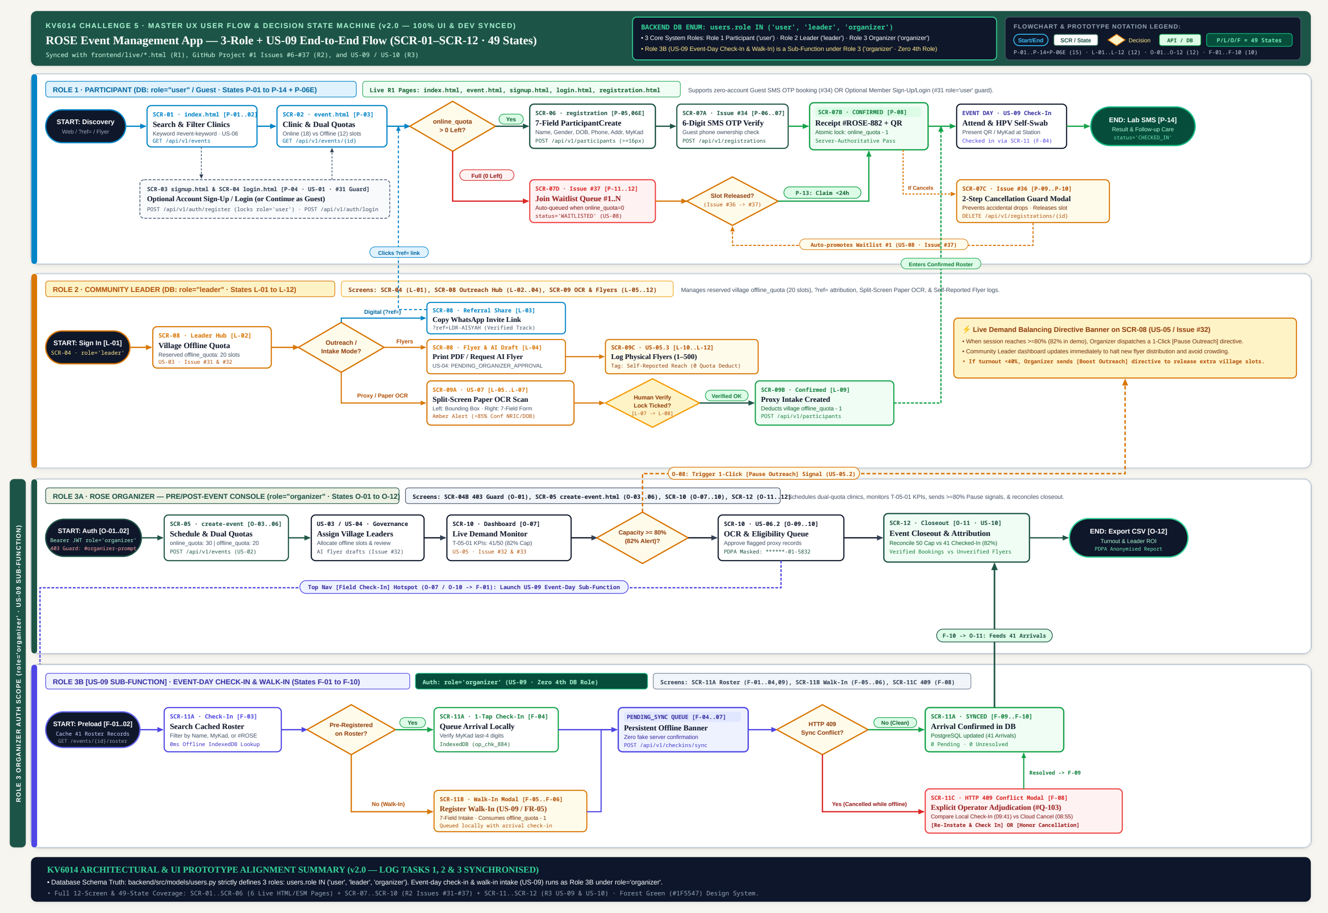
Figure 5: End-to-End Multi-Role UX User Flow & 49-State Interactive Prototype Decision State Machine (v2.0 — Mapping SCR-01..SCR-12, FastAPI Endpoints, and US-09 Sub-Function).
Screen ID & Title | Release & GitHub Issues | PM User Story | Frontend File & Module | Exact DOM IDs & Form `name` Attributes | Backend FastAPI Endpoint & Schema
SCR-01  Public Event List & Search | R1 (Implemented)  #17, #18, #19 | US-06 (T-06-01)  US-02 | frontend/live/index.html  events.mjs | #event-keyword (name='keyword'), #clear-search, #results-summary, #page-number, .masthead, #account-slot | GET /api/v1/events  Query: page, pageSize, keyword -> PaginatedEventResponse
SCR-02  Event Detail & Capacity View | R1 (Implemented)  #17, #18, #19 | US-02 (T-02-01)  US-06 (T-06-01) | frontend/live/event.html  event-detail.mjs | #detail-status (.status-badge), #not-accepting, #detail-retry, #choose-event ('Apply for this event ->') | GET /api/v1/events/{public_id}  Returns EventResponse (online_quota, offline_quota, status=ACTIVE)
SCR-03  Account Registration | R1 (Implemented)  #23, #24, #25, #10, #31 | US-01 (T-01-01, T-01-02) | frontend/live/signup.html  signup.mjs | input[name='username'] (3-20), input[name='password'] (>=6), select[name='role'] (user|organizer|leader) | POST /api/v1/users  Body: UserCreate -> 201 UserResponse (ULID id, UserRole Enum)
SCR-04  Role-Aware Sign In | R1 (Implemented)  #7, #8, #9, #10 | US-01 (T-01-01) | frontend/live/login.html  login.mjs, session.mjs | input[name='username'], input[name='password'], button ('Log in'), #account-slot | POST /api/v1/auth/login (or /auth/token)  GET /api/v1/users/me -> Bearer JWT
SCR-05  Organizer Create Event | R1 (Implemented)  #12, #13, #14, #32 | US-02 (T-02-01, T-02-02) | frontend/live/create-event.html  create-event.mjs | #auth-notice, #login-prompt, #organizer-prompt, title, overview, location, online_quota, offline_quota, start_time, end_time | POST /api/v1/events  Body: EventCreate (Organizer Bearer Token required; 403 otherwise)
SCR-06  Participant Application Form | R1 (Implemented)  #20, #21, #22, #26 | US-06 (T-06-01, T-06-02) | frontend/live/registration.html  registration.mjs | first_name (<=20), last_name (<=20), gender (male/female), date_of_birth, phone (<=20), address (opt), national_id (opt <=50) | POST /api/v1/participants  Body: ParticipantCreate (UserGender Enum) -> 201 ParticipantResponse
SCR-07  OTP, Receipt & Waitlist Center | R2 (Planned Ready)  #34, #35, #36, #37 | US-08 (T-08-01~03)  US-06 | Planned: my-bookings.html  (extends registration.mjs) | #otp-code, #booking-status-badge, #btn-cancel-booking, #waitlist-offer-banner | POST /api/v1/auth/otp, GET /api/v1/participants/me, PUT /api/v1/registrations/{id} (cancel/waitlist)
SCR-08  Community Leader Promotion Hub | R2 (Planned Ready)  #31, #32 | US-03 (T-03-01)  US-04 (T-04-01~03) | Planned: leader-hub.html  (aligned with mock v1.2.1) | #leader-quota-bar, #referral-link-box, #btn-copy-whatsapp, #btn-generate-brochure, #btn-download-flyer | GET /api/v1/events/{id}/leader-quota  POST /api/v1/events/{eventId}/brochures/generations
SCR-09  Leader Proxy, OCR & Flyer Report | R2 (Planned Ready)  #32, US-07 Split | US-07 (T-07-01~03)  US-05 (T-05-03) | Planned: leader-assist.html  (aligned with mock v1.2.1) | #btn-scan-paper-form, #ocr-review-banner, 7-field proxy form, #flyers-distributed-input (1-500) | POST /api/v1/ocr/scan-form, POST /api/v1/participants (offline pool), POST /api/v1/outreach-reports
SCR-10  Organizer Live Demand Monitor | R2 (Planned Ready)  #32, #33 | US-05 (T-05-01~03)  US-06.2, US-02 | Planned: organizer-dashboard.html | #stat-confirmed, #stat-pending-review, #stat-waitlist, #stat-reported-flyers, #btn-signal-pause, #btn-send-notice | GET /api/v1/events/{id}/summary (shared T-05-01 aggregation), POST /api/v1/events/{id}/notices
SCR-11  Field Offline Check-In & Walk-In | R3 (Planned W10-12)  US-09 Story Map | US-09 (T-09-01~03) | Planned: field-checkin.html  (aligned with mock v1.2.1) | #roster-revision-tag, #checkin-search, #btn-queue-checkin, #sync-queue-list, #btn-register-walkin | GET /api/v1/events/{id}/roster, POST /api/v1/checkins/sync (idempotent op_id -> SYNCED | CONFLICT)
SCR-12  Event Closeout & Review Summary | R3 (Planned W10-12)  US-10 Story Map | US-10 (T-10-01~03)  US-03 (T-03-03) | Planned: event-closeout.html | #closeout-metrics-grid, #attribution-comparison-table, #no-show-rate-card, #btn-export-csv | GET /api/v1/events/{id}/closeout-summary (reuses T-05-01 shared aggregation component)

4. Security, Privacy (Malaysian PDPA) & Low-Resource UX Controls
In alignment with the Cyber Consultant's Risk Assessment (Log Task 1) and Security Features Specification (Log Task 2), the UI enforces four mandatory protective controls:
1. Role-Based Access Control (RBAC) UI Guards: All privileged views (`SCR-05`, `SCR-08`, `SCR-10`, `SCR-11`, `SCR-12`) validate JWT role permissions both in the UI (`#login-prompt` and `#organizer-prompt` banners) and on the FastAPI server (`HTTP 403 Forbidden` for unauthorized roles).
2. Data Minimization & Clinical Privacy Boundary (PDPA Compliance): The online registration form (`SCR-06`) collects only the 7 essential identity and contact fields (`first_name`, `last_name`, `gender`, `date_of_birth`, `phone`, `address`, `national_id`). Sensitive medical or sexual-history questions are never asked on the web form and are deferred to private on-site nurse consultations.
3. Ephemeral OCR Image Handling & Scoped Offline Cache: Paper registration photos captured in `SCR-09` are used transiently for text extraction and human verification without persistent public caching. Offline field rosters in `SCR-11` preload only minimal attendee lookup fields with a strict expiration window.
4. Anti-Enumeration & Safe Cancellation Tokens: Self-service booking lookup and cancellation links (`SCR-07`) require phone OTP verification (`#34`) or unguessable time-limited tokens rather than sequential integer IDs, and mutations are never triggered by HTTP `GET` requests (preventing WhatsApp link-preview bots from accidentally cancelling a woman's screening slot).

